Creating a new project
In the terminal, we can change into the directory where our projects are stored. In my case this would be the Sites folder, it may be different for you. Then create a new directory for our REST API project. Then we can immediately change into this new directory
1  2 | mkdir divrhino-trivia  cd divrhino-trivia

Getting started with Docker
Our project folder is currently empty. Since we’re using Docker to create an app from scratch, the first file we will add is the Dockerfile. Then we will also add a docker-compose.yml file because we will need to manage multiple containers.
1  2  3 | touch Dockerfile  touch docker-compose.yml
Dockerfile
First we will look at the Dockerfile.
To begin, we want to start building our own container FROM the official golang image. And we want to use a specific version of the image. In this tutorial, we will use version 1.19.0. Specifying the version will ensure all our dev environments are the same. Think of this step like we’re installing Go onto our machine.
The only other thing we will do in this step is to specify our working directory. Docker containers run on Linux, so here we’re saying that we want our app to live in the /usr/src directory of the Linux filesystem in a project folder we want to be named app.
1  2  3  4 | FROM golang:1.19.0  WORKDIR /usr/src/app
We will continue building on our Dockerfile, but this is good enough to get us started. Let’s move on to our initial docker-compose.yml configuration.
docker-compose.yml
If our app required only one service, we would be able to make do with having just the Dockerfile above. However, we’re eventually going to add a Postgres service as well. So it would be handy to have a docker-compose.yml file to help us manage our container collection.
We’re starting off with a web service. We’ve called it web because this is the container where we will have our Go Fiber web app. Below is a brief explanation of each of the fields:
Field name |  | Description
build |  | This is the path to the Dockerfile for the service. We use . because the Dockerfile for our web service can be found in the same folder as our docker-compose.yml file.
ports |  | This is were we map the port from the container with our host computer. Our web service will be running on port 3000.
volumes |  | Volumes are used to persist data generated by the service. We want to persist our web service data inside our project directory, i.e. /usr/src/app.
1  2  3  4  5  6  7  8  9 | version: "3.8"  services:  web:  build: .  ports:  - "3000:3000"  volumes:  - .:/usr/src/app
And with that, we can head into our terminal and run our app using the following command:
1 | docker compose up
Because it’s our first time running our service, this command will pull the images we need. You will notice that the logs in our console correspond with the commands in our Dockerfile. Let’s kill our container now and go have a little look inside.
We can enter our container by running the following command. Here we’re saying we want to open the bash within our web service:
1 | docker compose run --service-ports web bash
Now inside our container, we can run commands like any other terminal. Let’s check our Go version:
1 | go version
We’ve successfully put together the most basic Docker setup needed to start developing with Go. In the next part of the tutorial, we will install the Go Fiber framework.

Dockerfile vs. docker-compose
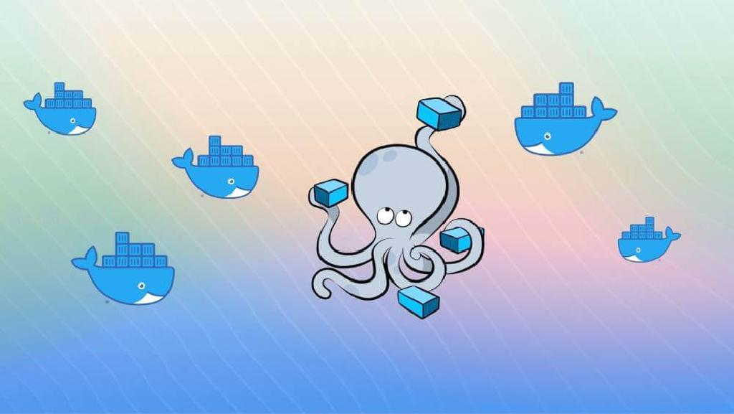
Before we go any further, let’s take a little detour to briefly discuss why we have both a Dockerfile and a docker-compose.yml file.
A Dockerfile is a set of commands that will be run to set up a container. Sometimes, it can help to think of it as the list of commands you’d need to run when setting up a brand new computer for development in a particular technology. In the case of this particular tutorial, we can think of it as the list of commands we’d need to run in order to set up a brand new computer for Go development. A project can have one or more Dockerfiles.
The docker-compose.yml file is a configuration file that will allow us to manage all our different containers. As we mentioned above, a project can have one or more Dockerfiles, which means it can be made up of one or more containers. The docker-compose.yml file can be thought of as a single project manager for all these containers.

